Effect Size, Power, Sample Size

1. Effect size – measures how large, how different, or how big an effect is for your experiment
   1. Unlike F, t, M, SD, or other statistics, effect size is standardized so that sample size should influence the scores.
   2. P values (and their related statistics F, t) are sensitive to sample size (this is why we talked about you can’t say something is “more significant”).
2. Types of effect sizes

|  |  |  |
| --- | --- | --- |
| Type | Description | How-To |
| Cohen’s d | Standardized difference between means  Tells you how many standard deviations the means are apart  Small = .2, medium = .5, large = .8  Can be positive or negative  Can get very large | General formula = (M – M) / SD, usually used for t-tests or combinations with pairs of means  - single t = (M-pop mean)/SD  - dep t = (M-M)/SDdifference scores  -ind t = (M-M)/Spooled  Look at Cohen’s D table |
| R2 | Proportion of variability accounted for by an effect  Useful when you have more than two means, gives you the total good variance with 3+ means  Small = .01, medium = .06, large = .15  Can only be positive  Range from .00 – 1.00 | More commonly used in regression, correlation  R2 = SSa/SStotal  Also can been found at the bottom of the ANOVA box in SPSS |
| Eta squared ɳ2 | Same as above.  SPSS for 1-factor ANOVA eta and R2 are same. | More commonly used in ANOVA as overall effect size  ɳ2 = SSa/SStotal  Also can been found in ANOVA box if options are selected |
| Partial eta squared ɳp2 | Same as above.  Here the effects are estimated based on the effect and error together (different denominator)  Useful with repeated measures designs and multiple factor designs, as it estimates for each effect | More commonly used in ANOVA as individual effect size  ɳp2 = SSa/(SStotal + SSa)  Also can been found in ANOVA box if options are selected |
| Omega squared ω2 | R2 and d tend to overestimate effect size  Omega squared is an R2 style effect size (variance accounted for) that estimates effect size on population parameters | Formula =  SSa – (a – 1)*MSs/a  SStotal + MSs/a  A = # groups  If this value is negative, you say that omega squared is zero |
| Partial omega squared ω 2 | Omega squared counterpart that is used to indicate the effect size for contrasts (i.e. pairwise comparisons) in ANOVA  Similar to d | Same formula, using the contrast F-values (would need to use ANOVA post hoc). |

1. Power – ability to find an effect when there is an effect present (say significant!).
   1. We control type 1 and type 2 by setting them at low rates to make sure we do not reject null spuriously, but also have power to reject
      1. Usually alpha = .05, type 1
      2. Usually beta = .20, type 2
      3. Power = 1 – beta = .80 (popular number)
   2. When to use?
      1. To calculate sample size needed for an experiment (most common! Super important!)
      2. To use current sample size and effect size to calculate achieved power – useful to know how many more people you have to run (or if it’s likely you’ll ever get an significant effect).
   3. Determinants of power
      1. Significance level = alpha
         1. More alpha (i.e. .05 over .01) gives you more power – usually you do not change this value
      2. Effect size
         1. Larger effect sizes have more power
         2. How do I even increase this value?
         3. It’s actually two parts (mean and standard deviation)
      3. Sample size
         1. Large sample sizes have the most power because they decrease the standard deviation (bad variance) of an estimate
         2. However – this is why effect size is so important: *Given a large enough sample size ANYTHING will be significant*. You have to think about statistical significance versus practical significance.
         3. 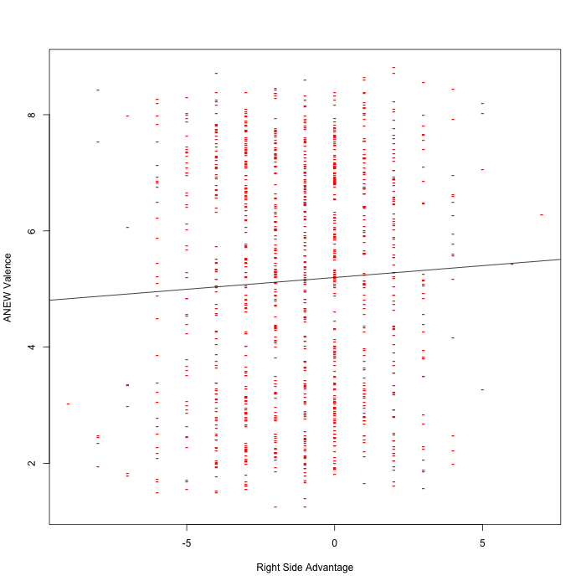
         4. An example of large sample size = significant effect
      4. Type of test (not in the book)
         1. Some tests are stronger than others – any repeated design is stronger because it reduces error variance – measuring people multiple times helps control bad variance
   4. Steps to determine sample size/power:
      1. Determine the type of experiment
      2. Figure out what you want to find in the experiment
      3. **Estimate an effect size – hardest part**
         1. Use previous research
         2. Use an idea from a pilot study
         3. Guess low
      4. Select power (usually .80)
      5. Select alpha (.05)
      6. Use G*Power!
2. Side note: DO NOT use SPSS’s observed power option. It’s a load of crap.

**Power:**

You want to check how many people you need to run (or alternatively, how many more people you need in a study).

Using G*Power, finding ideal participant numbers is fairly easy. Set up options:

* Test family: F-tests
* Statistical Test: ANOVA:
  + Between subjects only: fixed effects omnibus, one-way
  + Repeated measures only: repeated measures, within factors
  + Factorial: fixed effects, special, main effects, and interactions
* Type of power analysis: A priori (most common)
* Effect size f: either guess at an effect size based on research, use a small effect size for good measure, or after a couple subjects run a prelim ANOVA and use the current effect size. (You can click determine to convert eta squared to f).
* Alpha = .05
* Power = .80
* Number of groups = conditions – 1

Hit calculate for the number of participants needed.

**Power:**

1. Open Gpower!
   1. Test family: F test
   2. Statistical test: ANOVA: fixed one way
   3. Pick an effect size (or calculate!)**
   4. Alpha normally .05
   5. Beta normally .80
   6. Groups – number of levels.
   7. Hit ok!

